**IS 428 – Visual Analytics for Business Intelligence**

**AY 2020/2021 T2**

**Estatelogics Visualization User Guide**

**Prepared For:**

Prof CAO Kai

**Prepared by G1T8:**

Annabel Tan (01326694)

Natasya Queentina (01369694)

Ng Swee Hong (01330663)

Tay Kian Hong (01318952)

Thin Xin Hui (01356509)

Table of Contents

1. Home Page 1

2. Map Tab 3

2.1. Map Exploration 3

2.2. Choropleth 5

3. Resale Counts 7

3.1. Town 7

3.2. Flat Type 9

4. Price 11

4.1. Town 11

4.2. Flat Type 14

4.3. Analysis 16

5. Regression Analysis 18

**Visualizing factors affecting Singapore’s HDB resale house prices – Application User Guide**

# Home Page

Upon entering the dashboard via the following link: <https://itssweehong.shinyapps.io/IS428_G1T8_estatelogics/>

Users will be redirected to the Homepage of **estatelogics**. In this page, the user will be able to get an understanding on what the project and visualization is about, the motivation, objectives, dataset sources and the tools used for the project and analysis.

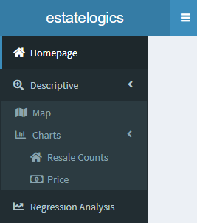

The homepage has a side panel which contains tabs for the user to switch views to.

The descriptive panel contains 2 tabs:

* the map tab allows the user to interact with a map of Singapore, to explore the various resale locations and amenities.
* The chart tab contains two additional sub-tabs,
  + resale counts which provide information with regards to number of resales,
  + price tab provides information with regards to the prices of the resales.

Finally, the regression analysis tab allows the user to tweak certain parameters to view an estimated price based on their selection.

All in all, the main aim of the visualization is to aid users who are planning to sell or buy a resale flat, come up with an estimated price, gain a better understanding of their location of interest or in general wants to gain a better understanding of Singapore’s resale market,

# Map Tab

The map tab consists of two panels, Map Exploration and Choropleth.

## Map Exploration

The map exploration panel consist of one main chart, a table and filter section. The user can use this panel to gain a better understanding of the spread of amenities and details of the resales for the various flat types, based on a certain year and range of average price per square meter:

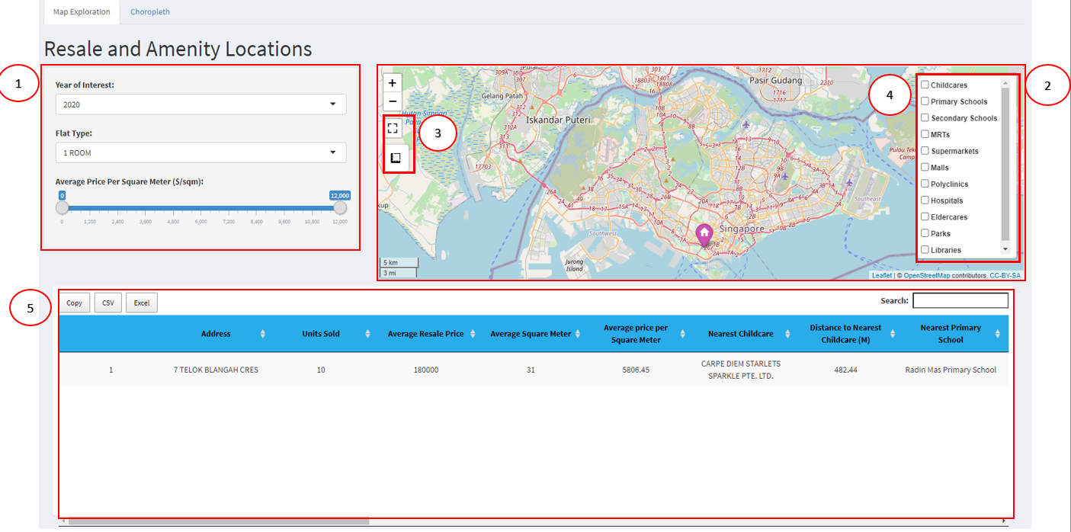

Use controls in box 1 to filter for resales for a certain year ranging from 2017 to 2021, to filter for specific flat types to be displayed, to filter for results within a certain average price per square meter range.

Use box 2 to navigate and view information about the resales around the country. Clicking on the various marks in the map will show information about the resales and amenities. In addition, use box 4 to toggle for various amenities on the list to be shown on the map.

Use controls in box 3 to toggle the map to be shown in full-screen, and to calculate the distance between two points.

Use box 5 to view information about resales in a table format, with the nearest establishment for each amenity and the distance to them in meters. The user can choose to search for a specific address or establishment, copy/extract the data in the table to their clipboard or excel/csv.

For example, users can filter for 4 room flats sold in year 2020 with average price per square meter ranging from $0 to $12,000, for locations of MRTs, Supermarkets and Malls to be displayed on the map:

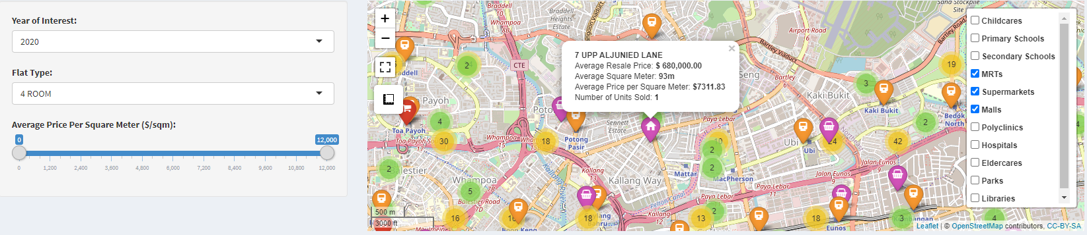

From the table, users can refer to the table to get the full information of each block. In the table, the user will get to know the **address** of the specific block, **total units sold** in that block, **average resale price**, **average square meter**, **average price per square meter**, **name of the nearest establishment** belonging to the various amenity categories and the **distance** from the block of interest to those establishments in **meters**:

## Choropleth

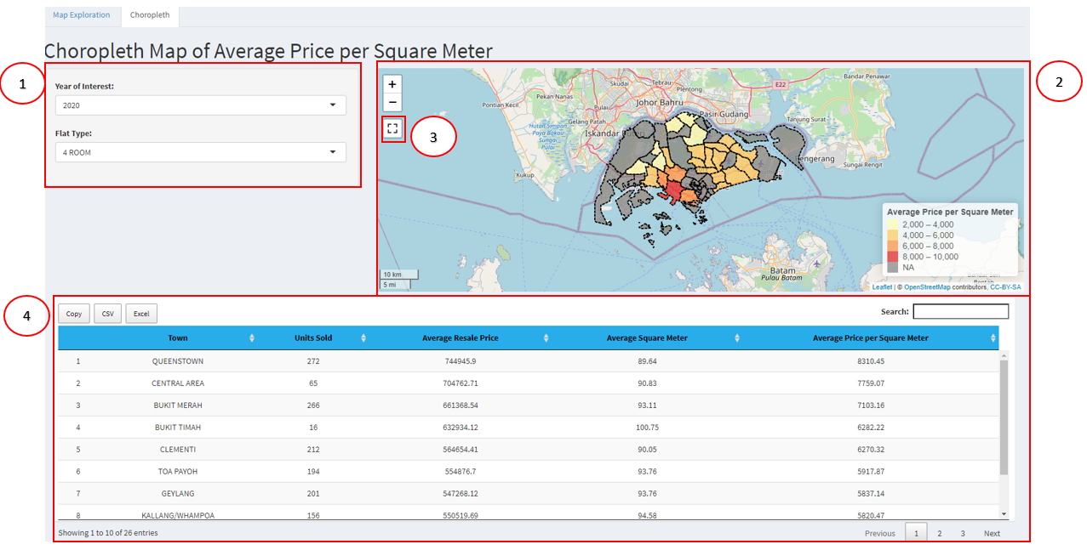Similarly, the choropleth panel consist of one main chart, a table and filter section. The user can use this panel to gain a better understanding of the distribution in terms of average price per square meter for the various flat types across the towns in Singapore for specific years. They will be able to identify which towns is the most expensive and cheapest for specific flat types.

Use controls in box 1 to filter for results for a certain year ranging from 2017 to 2021, to filter for results pertaining to a specific flat type of interest.

Use box 2 to navigate and view information about the various towns. In addition, use box 3 to toggle for the map to be shown in full screen.

Use box 4 to view information about the towns in a table format, with the number of units sold, average resale price, average square meter and average price per square meter. The user can choose to search for a specific town, copy/extract the data in the table to their clipboard or excel/csv.

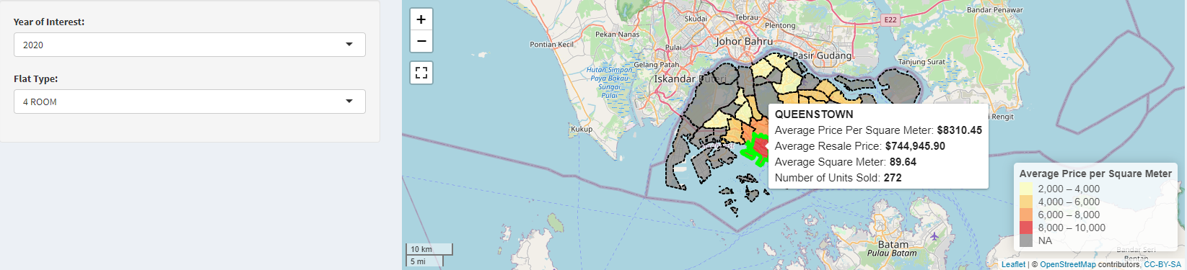For example, below shows result for 4-room flats in year 2020. When the cursor is placed on a specific town, such as Queenstown in this case, it displays information such as the average price per square meter, average resale price, average square meter and number of units sold:

At the bottom of the map, the table allows user to view the **total number of units sold**, **average resale price**, **average square meter**, **average price per square** **meter** of each town with 4 room flat transactions:

# Resale Counts

The resale counts tab consists of two panels, Town and Flat Type.

## Town

The town panel consist of two main charts and a filter section. The user can use this panel to gain a better understanding of the distribution of resales in terms of number of units sold at a town level.

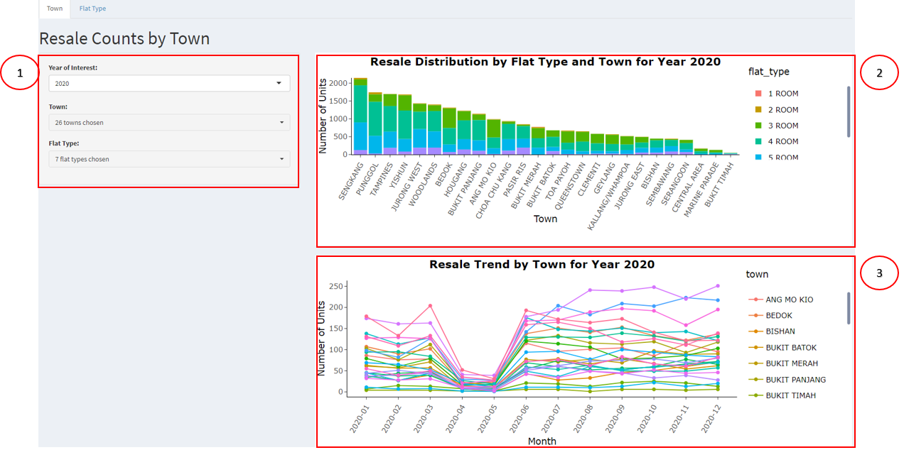

Use controls in box 1 to filter for results pertaining to a specific year, for various towns and flat types.

Double click on any of the legends in box 2 to let the chart display results for a specific flat type, drag and highlight any portion of the chart to zoom into the specific area. Double click the chart to return to the original view.

Double click on any of the legends in box 3 to let the chart display results for a specific town, drag and highlight any portion of the chart to zoom into the specific area. Double click the chart to return to the original view.

Place the cursor on top of any of the points in the chart to view specific details for the point.

To illustrate, in this tab, the user can get an insight of the resale distribution in terms of the **number of units** **sold** (Resale Counts) across different **towns**that are segmented by the various **flat types**. The hovering details will show the **number of units sold** in the specific **town** and **flat type**.

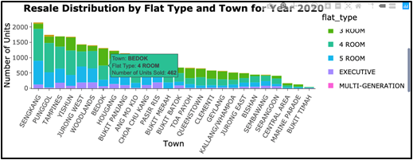

Next, a time series graph shows the resale trend by each **town**, across the different **months** in a specific **year**. The details can be viewed upon hovering. The hovering details will show the **number of units** sold in each **town** and **month** of the year.

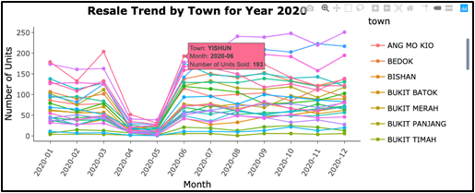

In addition, users can filter for 3-, 4- and 5-room flats in Ang Mo Kio, Bedok and Yishun to be shown:

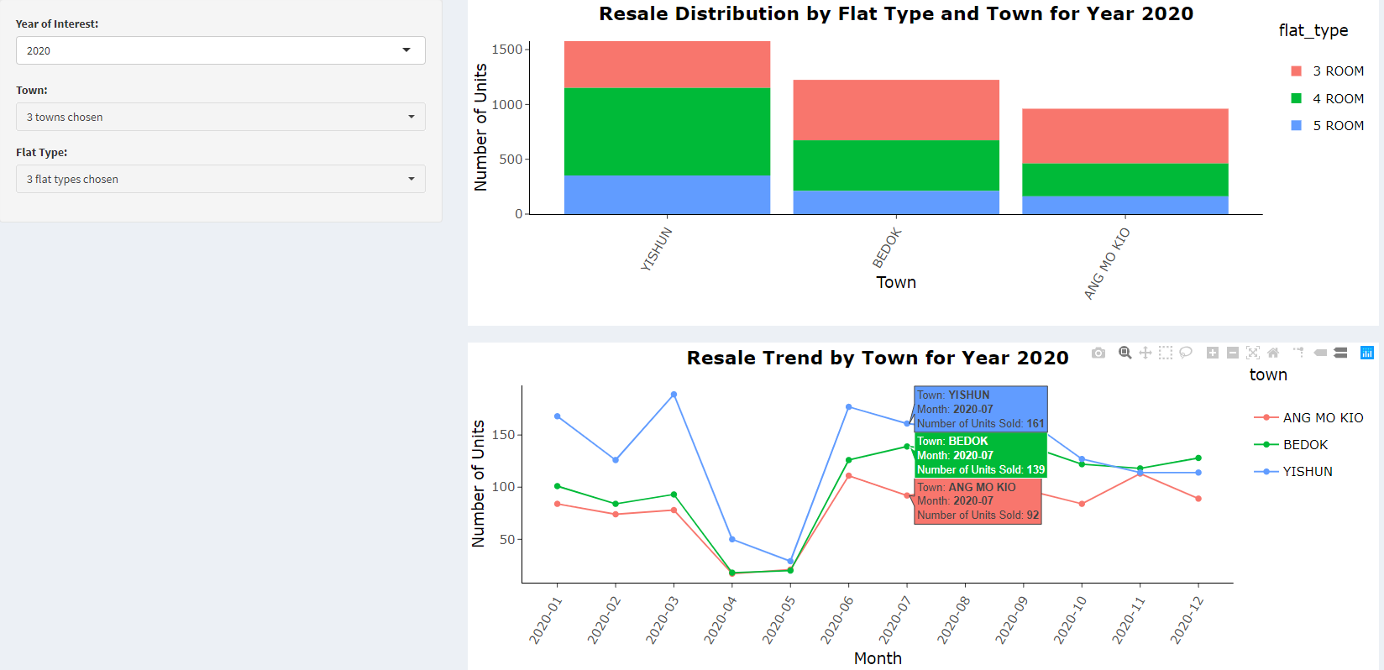

## Flat Type

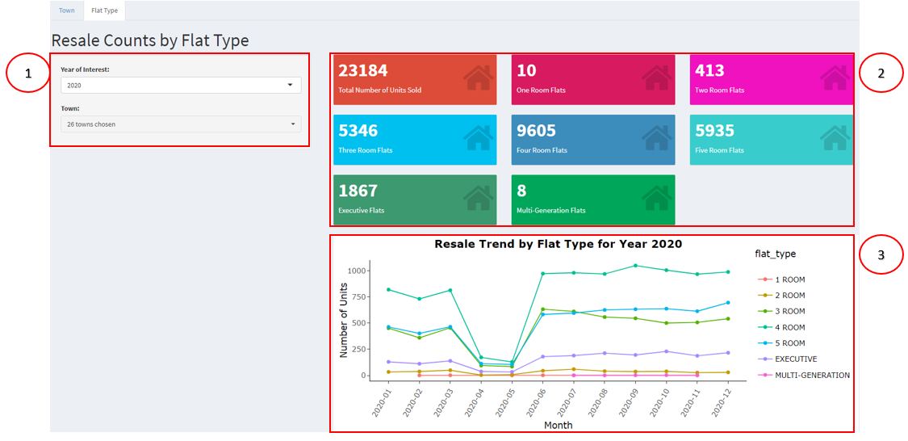The flat-type panel consist of one main chart, a filter section and 8 numeric value boxes. The user can use this panel to gain a better understanding of the distribution of resales in terms of number of units sold at a flat-type level.

Use controls in box 1 to filter for results pertaining to a specific year of interest and various towns.

Box 2 provides the information of number of units sold for the various flat types based on the selected filters.

Double click on any of the legends in box 3 to let the chart display results for a specific flat type, drag and highlight any portion of the chart to zoom into the specific area. Double click the chart to return to the original view.

Place the cursor on top of any of the points in the chart to view specific details for the point.

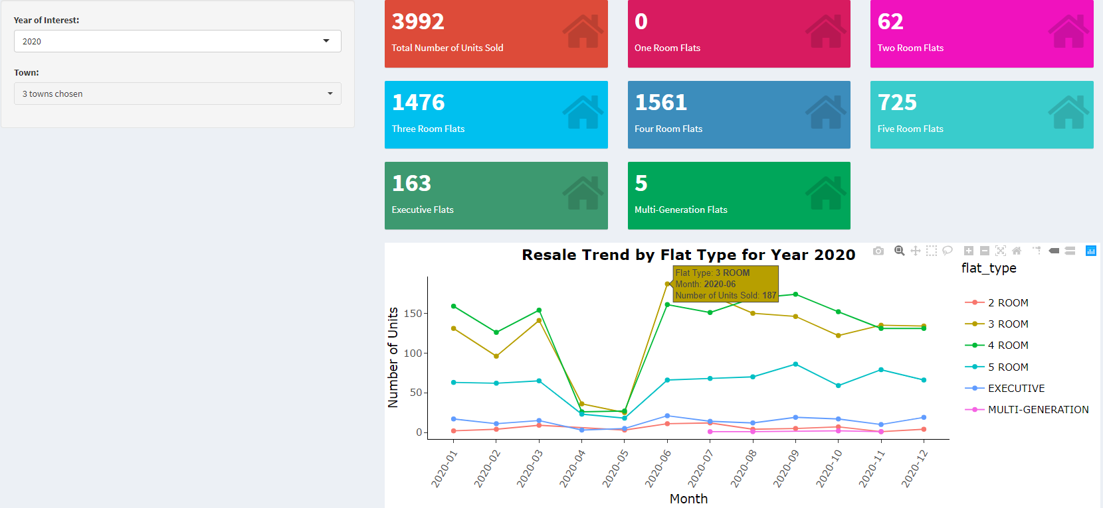For example, the user can filter for results in year 2020 and for Ang Mo Kio, Bedok and Yishun to be shown:

# Price

The price tab consists of three panels, Town, Flat Type and Analysis.

## Town

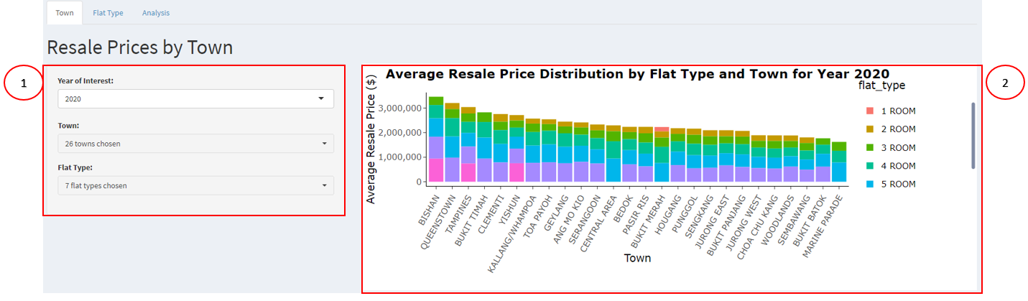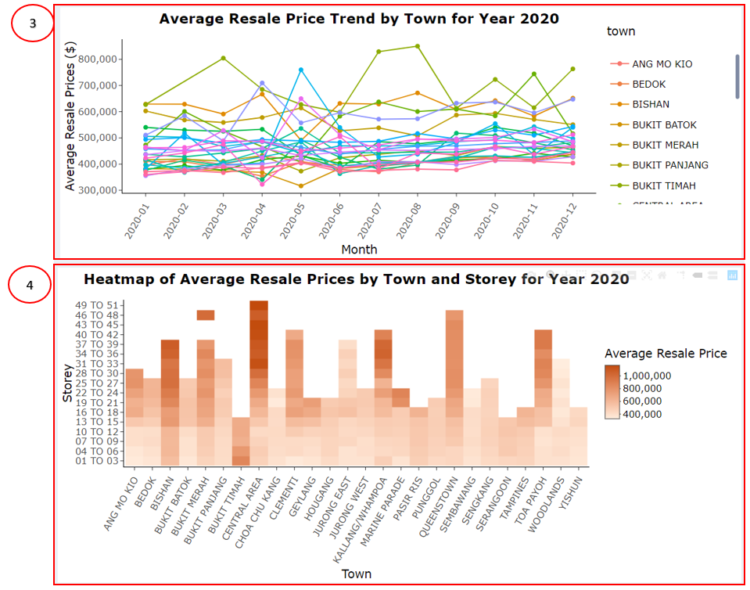The town panel consists of three main charts and a filter section. The user can use this panel to gain a better understanding of the distribution of resales in terms of average resale price at a town level.

Use controls in box 1 to filter for results pertaining to a specific year, to select the towns and flat types of interest.

Double click on any of the legends in box 2 to let the chart display results for a specific flat type, drag and highlight any portion of the chart to zoom into the specific area. Double click the chart to return to the original view.

Double click on any of the legends in box 3 to let the chart display results for a specific town, drag and highlight any portion of the chart to zoom into the specific area. Double click the chart to return to the original view.

Place the cursor on top of any of the points in the chart to view specific details for the point.

To illustrate, the heatmap graph shows the **average resale price** across the different **towns** at a **storey** level. Using color scheme on the **average resale price** helps to enhance the visualization by having different shades for the different **price** ranges. The darker color of the heatmap represents a higher average resale price. The hovering details will show the **average resale price** by **storey range** for each individual **town**.

The Stacked Bar graph shows the average resale price distribution across the different **towns** by all **flat Types.** The hovering details will show the **average resale price** of a specific **town** and **flat type.**

A Time Series graph shows the average resale price trend for each **town**, across the different **months** in a specific **year**. The hovering details will show the **average resale price** in each specific **town** and **month**.

## Flat Type

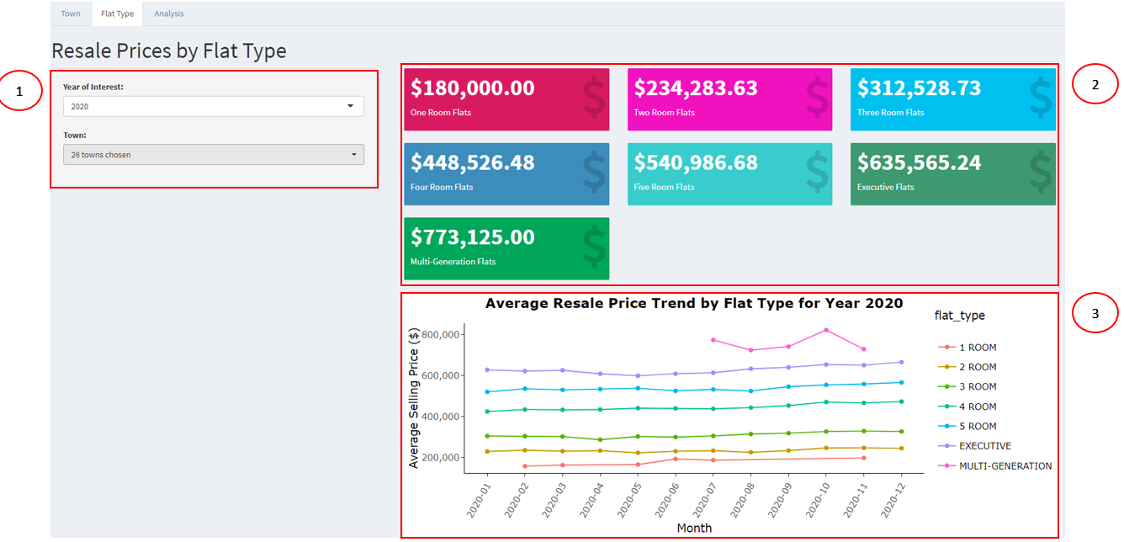The flat-type panel consist of one main chart, a filter section and 7 numeric value boxes. The user can use this panel to gain a better understanding of the distribution of resales in terms of average resale prices at a flat-type level.

Use controls in box 1 to filter for results pertaining to a specific year, to select the towns of interest.

Box 2 provides the information of average resale prices for each flat type based on the selected filters.

Double click on any of the legends in box 3 to let the chart display results for a specific flat type, drag and highlight any portion of the chart to zoom into the specific area. Double click the chart to return to the original view.

Place the cursor on top of any of the points in the chart to view specific details for the point.

For example, the user can filter for results in year 2020 and for Ang Mo Kio, Bedok and Yishun to be shown:

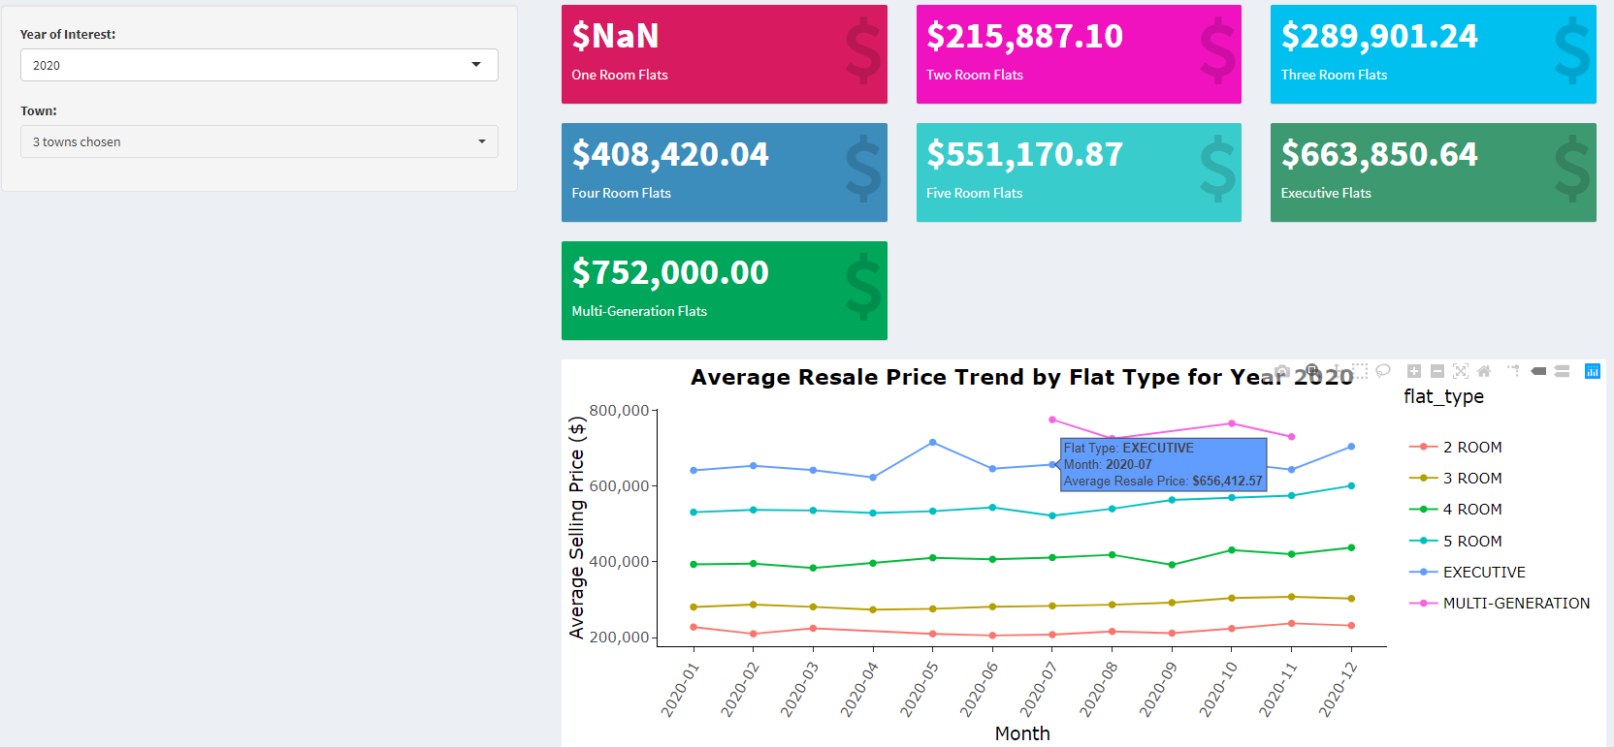

## Analysis

The analysis panel consist of two main chart and a filter section. The user can use this panel to gain a better understanding of the relationship of the various factors available against the resale prices, to understand how they would affect resale prices.

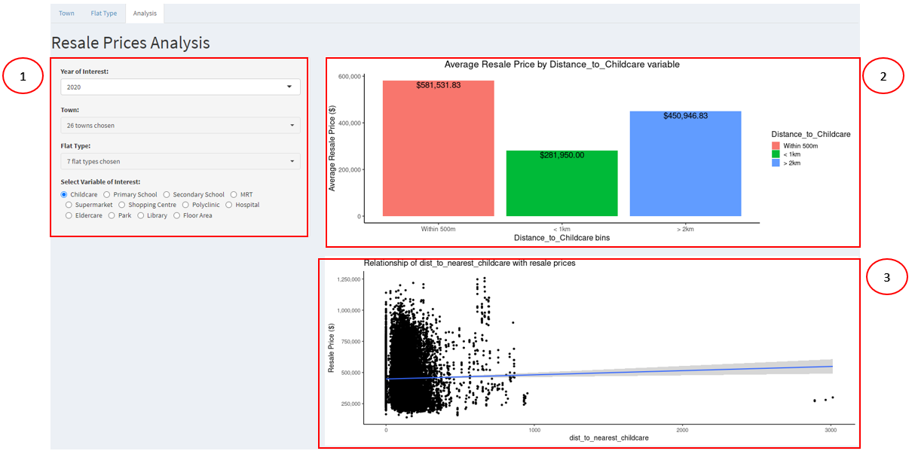

Use controls in box 1 to filter for a specific year, town, flat type and variable of interest.

Box 2 shows the average resale prices based on certain numeric bins.

Box 3 shows the relationship of the selected variable with the resale price by plotting a scatter plot with a linear regression line.

To illustrate, users can freely decide on the X axis variable which includes the distance to the 11 amenities and the floor area depending on what they are interested in. On top of that, user can also filter the results by choosing a specific **year** of Interest and an option to select multiple **towns** and **flat types**.

For example, when distance to childcare is selected as the analysis variable, the bar graph shows the average resale price of flats by the **numeric bin categories** (e.g. Within 500m, <1km, >2km) based on the selected variable.

At the bottom, the users can understand the relationship between the **resale price** and the **chosen variable** by the scatter plot with a linear line plotted.

# Regression Analysis

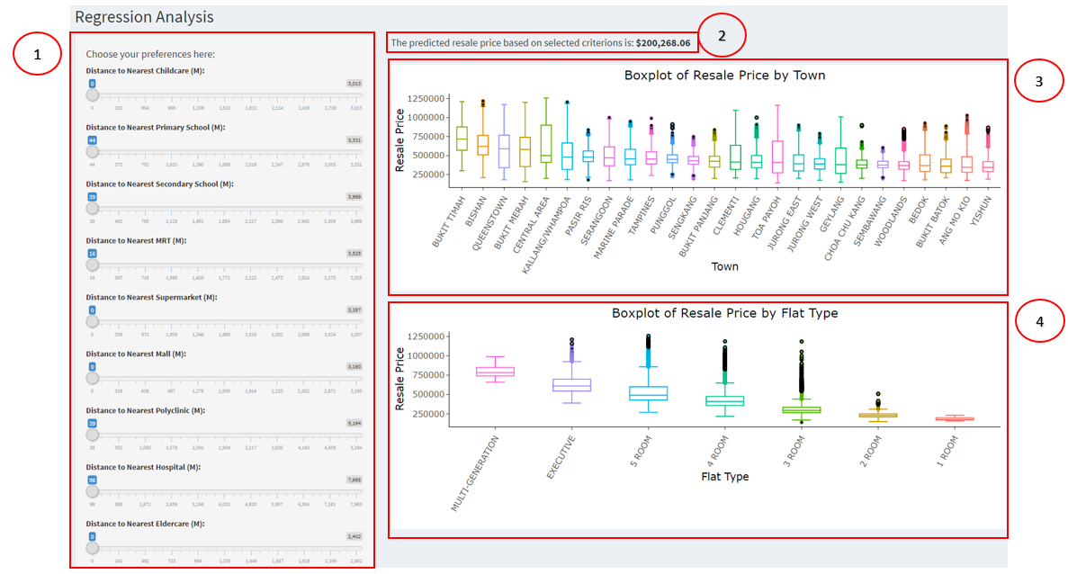The regression analysis tab allows the user to generate an estimated price based on various parameters available.

Use controls in box 1 to select the value for each parameter to generate an estimated price.

Box 2 provides the estimated price based on selections.

Box 3 contains the box plot based on decreasing median prices for the various towns for all flat types.

Box 4 contains the boxplot based on decreasing median prices for the various flat types.

To illustrate, in this page, user can predict the prices of resale flats by choosing their preferred **distances** for each of the **amenities** and also by stating 1 or 0 on the different **flat types** to indicate which flat type they are interested in (1 for yes and 0 for no)**.**

The first boxplot illustrates the predicted resale price across different **towns**. The hovering details will show the **max**, **median** and **min** of the **resale price** along with the **Q1** and **Q3** results.

Followed by the second boxplot that shows the predicted resale price for each **flat type.** The hovering details will show the **max**, **median** and **min** of the **resale price** along with the **Upper** **Fence**, **Q1** and **Q3** results.

